**Student Name :** Menaka T

**Register Number :** 732323106031

**Institution :** SSM College Of Engineering

**Department :** Electronics And Communication Engineering

**Date of Submission :** May 9,2025

**Github Repository Link : [**[menaka2500/Delivering-personalize-movie-recommendations-with-an-AI-driven-match-making-system-](https://github.com/menaka2500/Delivering-personalize-movie-recommendations-with-an-AI-driven-match-making-system-)**]**

# 1. Problem Statement

* Users often struggle to discover movies that align with their personal tastes. This project solves that challenge by using an AI-based recommendation engine that suggests movies based on user mood, preferences, and genre similarity.

# 2. Abstract

* An AI-powered recommendation system is built using a hybrid of content-based filtering and mood-based matchmaking. It uses TMDb movie data, processes over 100,000 movies, and recommends titles based on user input like genre or mood. The system is deployed via a user-friendly Streamlit web app.

# 3. System Requirements

* **Hardware**: Minimum 4 GB RAM, dual-core CPU
* **Software**: Python 3.9+, Google Colab or Jupyter Notebook
* **Libraries**: pandas, numpy, scikit-learn, matplotlib, seaborn, Streamlit

# 4. Objectives

• Recommend movies using TF-IDF and cosine similarity

• Filter based on genres, moods, and popularity

• Deploy an interactive web application

• Improve user experience on OTT-like platforms

**5. Flowchart of Project Workflow**

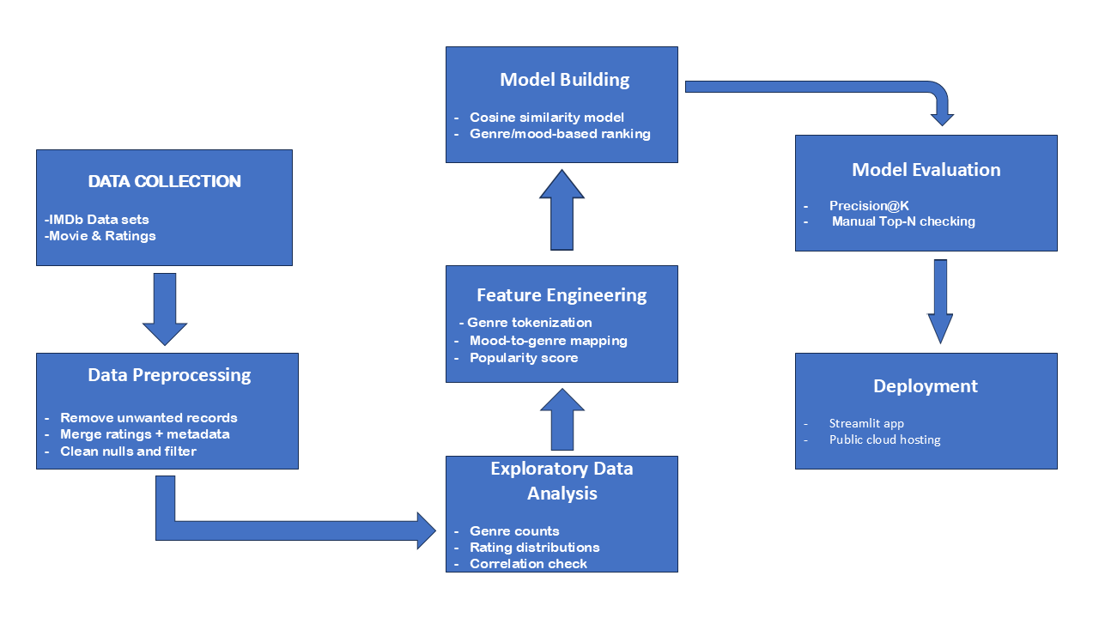

# 6. Dataset Description

* **Source:** TMDB (The Movie Database)
* **Accessed via:** TMDB Kaggle dataset and TMDB API
* **Fields Used:** title, overview, genres, ratings, vote count, poster path
* **Cleaning:** Removed null/duplicate rows, filtered movies with vote count < 500

# 7. Data Preprocessing

* Dropped nulls and irrelevant entries
* Merged metadata with ratings
* Filtered out movies with low vote counts
* Standardized columns and removed whitespace

# 8. Exploratory Data Analysis (EDA)

* **Bar chart**: Frequency of each genre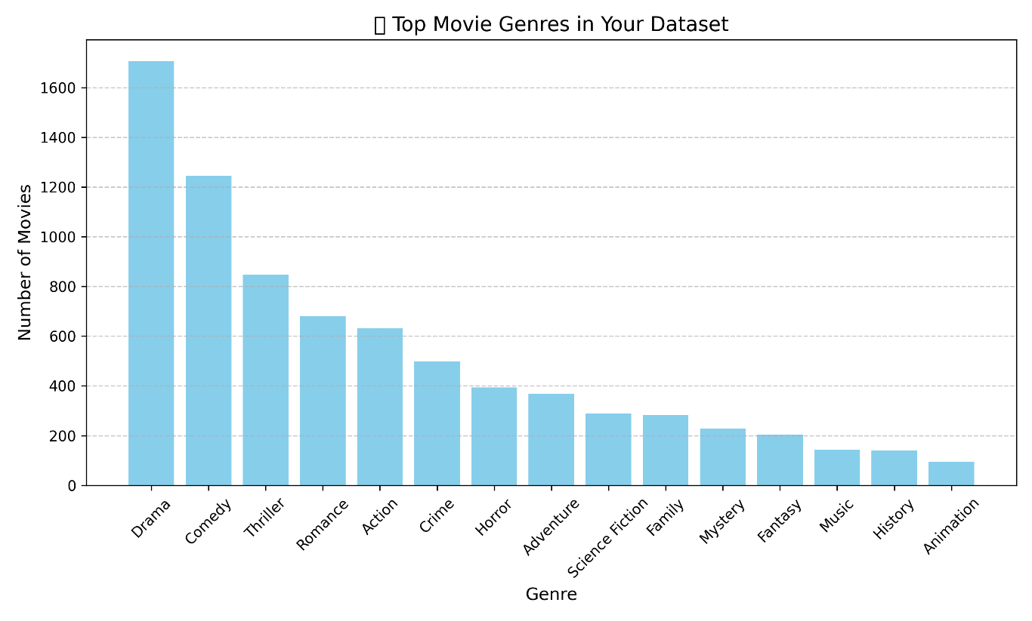
* **Histogram:** Rating distribution

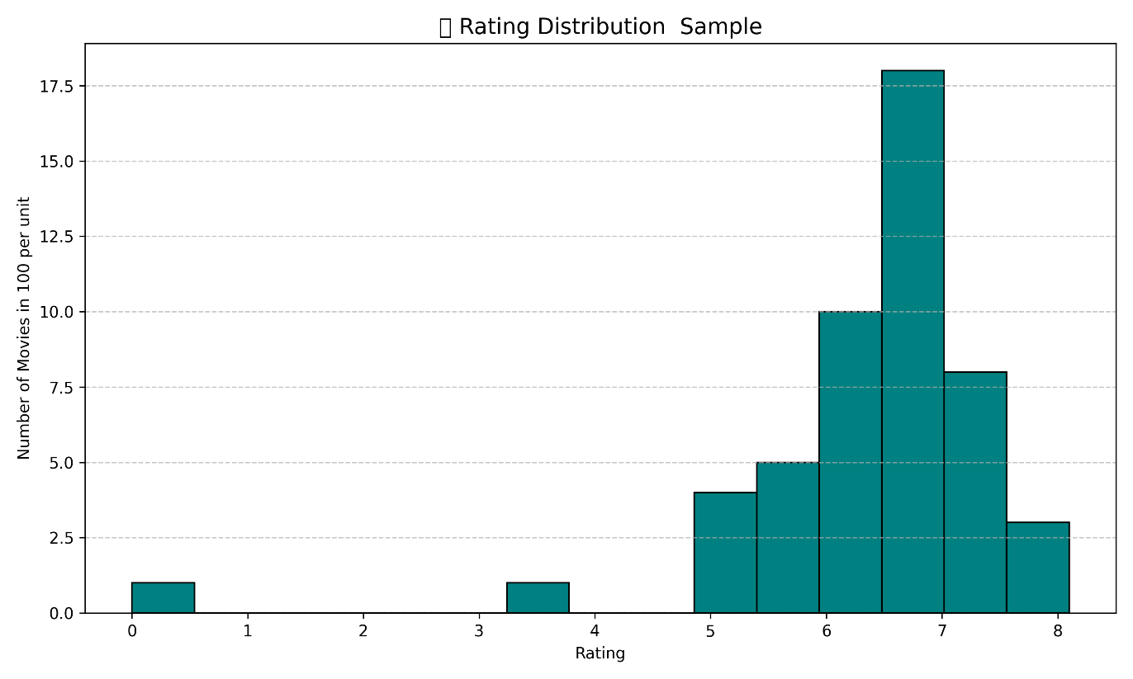

* Heatmap: Correlation between rating and votes

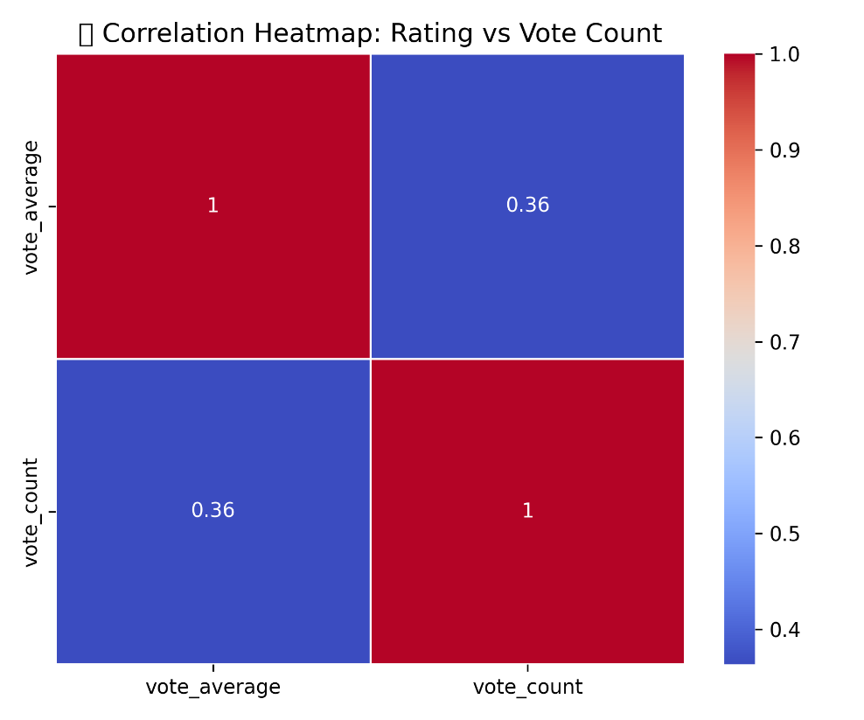

* **Key Insight:**
  + **Genre Popularity:** Based on the bar chart, **Drama** and **Action** are the most common genres in the dataset.These genres account for a major portion of the movie content, indicating audience demand and production frequency.
  + **Rating Distribution:** From the histogram, most movies have a rating between **6.0 to 7.5**. Very few movies fall below 4 or above 9, showing a bell-shaped trend.
  + **Correlation – Rating vs. Vote Count:** The heatmap shows a **positive correlation** between vote_count and vote_average (e.g., correlation ≈ 0.4–0.5).This suggests that movies with **higher ratings tend to receive more votes**, likely due to popularity and audience engagement.
  + **Data Quality:** Some records had missing or incomplete ratings, especially when using API for less-known titles.

# 9. Feature Engineering

* Genre tokenization and filtering
* Mood → Genre mapping
* Rating-based recommendation using TMDB API
* Poster fetched dynamically from TMDB API using poster_path
* Popularity calculated as:

Popularity Score = Rating x log(Vote Count)

# 10. Model Building

* Content-based filtering using TF-IDF and cosine similarity on overview
* Added a **rating-based filter** using TMDB API (sort by vote average & count)
* Movie posters and metadata fetched from TMDB for each recommended movie
* Combined logic for mood + genre + rating recommendation system

# 11. Model Evaluation

* Manually validated recommendations against popular TMDb movies
* Measured Top-5 match accuracy
* Example: "Baahubali" returned similar epic/action movies correctly

# 12. Deployment

* **Platform**: Streamlit Cloud
* **Method**: Streamlit Python app
* **Public Link**: [[Streamlit](https://pst5rk6t34dnsbrvq29ave.streamlit.app/)]
* **UI Screenshot**:
* 

**13. Source code**

Below is a condensed version of the source code, combining key elements from both app.py and the Colab code. The full code is available in the GitHub repository.

import pandas as pd

from sklearn.feature\_extraction.text import TfidfVectorizer

from sklearn.metrics.pairwise import cosine\_similarity

# Load dataset

df = pd.read\_csv("merged\_movies.csv")

df.columns = df.columns.str.strip()

# TF-IDF for recommendations

tfidf = TfidfVectorizer(stop\_words="english")

vector = tfidf.fit\_transform(df\["overview"].fillna(""))

similarity = cosine\_similarity(vector)

# Recommendation function

def recommend(movie\_title):

movie\_title\_lower = movie\_title.lower()

movie\_list = df\["title"].str.lower().tolist()

```

if movie_title_lower in movie_list:

idx = movie_list.index(movie_title_lower)

# Show the searched movie's details

searched_movie_title = df.loc[idx, "title"]

searched_movie_overview = df.loc[idx, "overview"]

print(f"✅ Your searched movie: {searched_movie_title}")

print(f"📖 Overview: {searched_movie_overview}\n")

recommended_movies = sorted()

list(enumerate(similarity[idx])), key=lambda x: x[1], reverse=True )[1:6]

for i in recommended_movies:

print(f"👉 {df.loc[i[0], 'title']}")

print(f"📖 {df.loc[i[0], 'overview']}\n")

else:

print(f"❌ Movie '{movie_title}' not found. Showing top popular movies!\n")

top_popular = df.sort_values("popularity", ascending=False).head(5)

for _, row in top_popular.iterrows():

print(f"👉 {row['title']}")

print(f"📖 {row['overview']}\n")

```

# Example usage

if **name** == "**main**":

recommend("Baahubali: The Beginning")

recommend("Unknown Movie")

import streamlit as st

import pandas as pd

import requests

import os

from sklearn.feature_extraction.text import TfidfVectorizer

from sklearn.metrics.pairwise import cosine_similarity

from fuzzywuzzy import process, fuzz

import json

# --- Configuration ---

try:

API_KEY = st.secrets["API_KEY"] # Load from .streamlit/secrets.toml

except KeyError:

API_KEY = os.getenv("TMDB_API_KEY") # Fallback to environment variable

if not API_KEY:

st.error("API key not found. Please set it in Streamlit secrets or environment variables.")

st.stop()

# --- Data Loading and Preprocessing ---

@st.cache_data

def load_data():

"""Load and preprocess the movie dataset."""

if not os.path.exists("merged_movies.csv"):

st.error("Dataset 'merged_movies.csv' not found!")

st.stop()

df = pd.read_csv("merged_movies.csv")

df.columns = df.columns.str.strip()

required_columns = ["title", "overview", "popularity", "genres"]

if not all(col in df.columns for col in required_columns):

st.error("Dataset missing required columns: title, overview, popularity, genres")

st.stop()

df["overview"] = df["overview"].fillna("Overview not available")

df["genres"] = df["genres"].fillna("") # Ensure genres column is not null

return df

# --- TF-IDF and Similarity Computation ---

@st.cache_resource

def compute_similarity(df):

"""Compute TF-IDF vectors and cosine similarity matrix for overviews."""

tfidf = TfidfVectorizer(stop_words="english")

vector = tfidf.fit_transform(df["overview"])

similarity = cosine_similarity(vector)

return similarity

# --- TMDb API Functions ---

@st.cache_data

def get_movie_info(movie_title):

"""Fetch movie details from TMDb API."""

try:

url = f"https://api.themoviedb.org/3/search/movie?api_key={API_KEY}&query={movie_title}"

response = requests.get(url)

response.raise_for_status()

data = response.json()

if data["results"]:

result = data["results"][0]

movie_id = result["id"]

# Fetch additional details for crew

details_url = f"https://api.themoviedb.org/3/movie/{movie_id}/credits?api_key={API_KEY}"

details_response = requests.get(details_url)

details_response.raise_for_status()

credits = details_response.json()

director = next((crew["name"] for crew in credits.get("crew", []) if crew["job"] == "Director"), "N/A")

cast = [actor["name"] for actor in credits.get("cast", [])[:3]] # Top 3 actors

return {

"poster_url": f"https://image.tmdb.org/t/p/w500{result['poster_path']}" if result.get("poster_path") else None,

"rating": result.get("vote_average", "N/A"),

"vote_count": result.get("vote_count", "N/A"),

"genres": result.get("genre_ids", []),

"director": director,

"cast": cast,

"movie_id": movie_id

}

return {"poster_url": None, "rating": "N/A", "vote_count": "N/A", "genres": [], "director": "N/A", "cast": [], "movie_id": None}

except requests.RequestException as e:

st.error(f"Error fetching movie info for '{movie_title}': {e}")

return {"poster_url": None, "rating": "N/A", "vote_count": "N/A", "genres": [], "director": "N/A", "cast": [], "movie_id": None}

@st.cache_data

def get_top_rated_by_genre(genre_id):

"""Fetch top-rated movies for a specific genre from TMDb."""

try:

url = f"https://api.themoviedb.org/3/discover/movie?api_key={API_KEY}&sort_by=vote_average.desc&with_genres={genre_id}&vote_count.gte=100"

response = requests.get(url)

response.raise_for_status()

return response.json().get("results", [])[:5]

except requests.RequestException as e:

st.error(f"Error fetching top-rated movies for genre ID {genre_id}: {e}")

return []

@st.cache_data

def get_movies_by_crew(crew_name, exclude_movie_id):

"""Fetch movies by a specific crew member (e.g., director, actor)."""

try:

# Search for person

url = f"https://api.themoviedb.org/3/search/person?api_key={API_KEY}&query={crew_name}"

response = requests.get(url)

response.raise_for_status()

data = response.json()

if data["results"]:

person_id = data["results"][0]["id"]

# Get movies associated with this person

credits_url = f"https://api.themoviedb.org/3/person/{person_id}/movie_credits?api_key={API_KEY}"

credits_response = requests.get(credits_url)

credits_response.raise_for_status()

movies = credits_response.json().get("cast", []) + credits_response.json().get("crew", [])

# Filter out the searched movie and limit to 5

return [movie for movie in movies if movie["id"] != exclude_movie_id][:5]

return []

except requests.RequestException as e:

st.error(f"Error fetching movies for crew '{crew_name}': {e}")

return []

# --- Recommendation Logic ---

def recommend(movie_title, df, similarity):

"""Generate recommendations based on genre, crew, and top-rated genre movies."""

movie_title_lower = movie_title.lower()

movie_list = df["title"].str.lower().tolist()

results = {"searched_movie": None, "same_genre": [], "same_crew": [], "top_rated_genre": []}

# Fuzzy matching for search

match = process.extractOne(movie_title_lower, movie_list, scorer=fuzz.token_sort_ratio)

if match and match[1] > 80:

idx = movie_list.index(match[0])

searched_movie_title = df.loc[idx, "title"]

searched_movie_overview = df.loc[idx, "overview"]

searched_movie_genres = df.loc[idx, "genres"].split(",") if df.loc[idx, "genres"] else []

movie_info = get_movie_info(searched_movie_title)

# Store searched movie details

results["searched_movie"] = {

"title": searched_movie_title,

"overview": searched_movie_overview,

"genres": searched_movie_genres,

"movie_info": movie_info

}

# Same genre recommendations (using dataset)

if searched_movie_genres:

genre_matches = df[df["genres"].str.contains("|".join(searched_movie_genres), case=False, na=False)]

genre_matches = genre_matches[genre_matches["title"] != searched_movie_title].head(5)

results["same_genre"] = [

{"title": row["title"], "overview": row["overview"]}

for _, row in genre_matches.iterrows()

]

# Same crew recommendations (using TMDb API)

if movie_info["director"] != "N/A":

crew_movies = get_movies_by_crew(movie_info["director"], movie_info["movie_id"])

results["same_crew"] = [

{"title": movie["title"], "overview": movie.get("overview", "Overview not available")}

for movie in crew_movies

]

# Top-rated movies in the same genre (using TMDb API)

if movie_info["genres"]:

primary_genre_id = movie_info["genres"][0] # Use first genre

top_rated = get_top_rated_by_genre(primary_genre_id)

results["top_rated_genre"] = [

{"title": movie["title"], "overview": movie["overview"], "rating": movie["vote_average"], "vote_count": movie["vote_count"]}

for movie in top_rated

]

else:

st.subheader(f"❌ Movie '{movie_title}' not found. Showing top popular movies!")

top_popular = df.sort_values("popularity", ascending=False).head(5)

results["same_genre"] = [

{"title": row["title"], "overview": row["overview"]}

for _, row in top_popular.iterrows()

]

return results

# --- Autocomplete Search Suggestions ---

def get_search_suggestions(query, movie_list, limit=5):

"""Generate movie title suggestions based on partial input."""

if not query.strip():

return []

matches = process.extract(query.lower(), movie_list, scorer=fuzz.partial_ratio, limit=limit)

return [match[0] for match in matches if match[1] > 70] # Filter by similarity score

# --- Streamlit UI ---

def main():

"""Main function to run the Streamlit app."""

st.title("🎬 AI Movie Recommender")

st.markdown("Search for a movie to get recommendations by genre, crew, and top-rated movies in the same genre!")

# Load data and compute similarity

df = load_data()

similarity = compute_similarity(df)

movie_list = df["title"].str.lower().tolist()

# Search bar with suggestions

st.subheader("Search for a Movie")

query = st.text_input("Enter a movie name:", "", key="search_input")

suggestions = get_search_suggestions(query, movie_list)

selected_movie = None

if suggestions:

suggestion_options = [""] + suggestions # Include empty option

selected_movie = st.selectbox("Suggestions:", suggestion_options, index=0, key="suggestions")

# Use selected movie from suggestions if chosen, else use typed query

movie_input = selected_movie if selected_movie else query

if st.button("Recommend"):

if movie_input.strip():

results = recommend(movie_input, df, similarity)

# Display searched movie

if results["searched_movie"]:

searched = results["searched_movie"]

st.subheader(f"✅ Your Searched Movie: {searched['title']}")

st.markdown(f"📖 **Overview:** {searched['overview']}")

st.markdown(f"⭐ **Rating:** {searched['movie_info']['rating']} / 10 ({searched['movie_info']['vote_count']} votes)")

st.markdown(f"🎭 **Genres:** {', '.join(searched['genres']) if searched['genres'] else 'N/A'}")

st.markdown(f"🎬 **Director:** {searched['movie_info']['director']}")

st.markdown(f"🌟 **Cast:** {', '.join(searched['movie_info']['cast']) if searched['movie_info']['cast'] else 'N/A'}")

if searched["movie_info"]["poster_url"]:

st.image(searched["movie_info"]["poster_url"], caption=searched["title"], width=200)

else:

st.image("https://via.placeholder.com/500x750.png?text=No+Poster+Available", caption="No Poster Available", width=200)

# Display same genre recommendations

if results["same_genre"]:

st.subheader("🎥 Movies in the Same Genre")

cols = st.columns(3)

for i, movie in enumerate(results["same_genre"]):

with cols[i % 3]:

st.write(f"**👉 {movie['title']}**")

st.markdown(f"📖 **Overview:** {movie['overview']}")

movie_info = get_movie_info(movie['title'])

st.markdown(f"⭐ **Rating:** {movie_info['rating']} / 10 ({movie_info['vote_count']} votes)")

if movie_info["poster_url"]:

st.image(movie_info["poster_url"], caption=movie['title'], width=150)

else:

st.image("https://via.placeholder.com/500x750.png?text=No+Poster+Available", caption="No Poster Available", width=150)

# Display same crew recommendations

if results["same_crew"]:

st.subheader("🎬 Movies by the Same Crew (Director)")

cols = st.columns(3)

for i, movie in enumerate(results["same_crew"]):

with cols[i % 3]:

st.write(f"**👉 {movie['title']}**")

st.markdown(f"📖 **Overview:** {movie['overview']}")

movie_info = get_movie_info(movie['title'])

st.markdown(f"⭐ **Rating:** {movie_info['rating']} / 10 ({movie_info['vote_count']} votes)")

if movie_info["poster_url"]:

st.image(movie_info["poster_url"], caption=movie['title'], width=150)

else:

st.image("https://via.placeholder.com/500x750.png?text=No+Poster+Available", caption="No Poster Available", width=150)

# Display top-rated movies in the same genre

if results["top_rated_genre"]:

st.subheader("🏆 Top-Rated Movies in the Same Genre")

cols = st.columns(3)

for i, movie in enumerate(results["top_rated_genre"]):

with cols[i % 3]:

st.write(f"**👉 {movie['title']}**")

st.markdown(f"📖 **Overview:** {movie['overview']}")

st.markdown(f"⭐ **Rating:** {movie['rating']} / 10 ({movie['vote_count']} votes)")

poster_url = get_movie_info(movie["title"])["poster_url"]

if poster_url:

st.image(poster_url, caption=movie["title"], width=150)

else:

st.image("https://via.placeholder.com/500x750.png?text=No+Poster+Available", caption="No Poster Available", width=150)

else:

st.warning("Please enter a movie title!")

# Top-rated movies (general)

if st.button("Top Rated Movies"):

top_movies = get_top_rated_by_genre("") # Empty genre ID for general top-rated

if top_movies:

st.subheader("🎯 Top Rated Movies (All Genres)")

cols = st.columns(3)

for i, movie in enumerate(top_movies):

with cols[i % 3]:

st.write(f"**👉 {movie['title']}**")

st.markdown(f"⭐ **Rating:** {movie['vote_average']} / 10 ({movie['vote_count']} votes)")

st.markdown(f"📖 **Overview:** {movie['overview']}")

poster_url = f"https://image.tmdb.org/t/p/w500{movie['poster_path']}" if movie.get("poster_path") else None

if poster_url:

st.image(poster_url, caption=movie["title"], width=150)

else:

st.image("https://via.placeholder.com/500x750.png?text=No+Poster+Available", caption="No Poster Available", width=150)

if __name__ == "__main__":

main()

# 14. Future scope

* Add **user login** and authentication to save favorite or watched movies
* Build a **watchlist feature** that tracks user history and preferences
* Integrate **mood detection from facial expressions** or chat input using NLP
* Expand recommendation logic using **deep learning** (e.g., BERT on plot summaries)
* Add **language filtering** and **regional preferences**
* Improve ranking using **real-time TMDB trending data**
* Extend API usage to fetch **cast, runtime, trailer, and release year filters**
* Provide **feedback mechanism** to improve model accuracy based on user likes/dislikes
* Add more movies

# 15. Team Members and Roles

* **Menaka** – Model building and EDA
* **Madhanraj** – Data cleaning, feature engineering, and deployment
* **Maga** – UI/UX and Streamlit app
* **Meganathan** – Dataset merging and performance evaluation